CHAPTER 1
INTRODUCTION

  - Motivation
The technology evolution and necessity has made the electronics system an integral part of human life. To fulfill the demand, a large number of functional units are embedded within a scaled-down tiny chip. Feature size scaling to meet the demand of the portability and performance issues increases the total power requirement of the chip. Consequently, the power density becomes high and there is thermal effect that reduces the performance and reliability of the circuit. Even the integrated circuit (IC) chip may burn out due to thermal runaway. Subsequently, thermal issues have become one of the cutting edge problems, and finding the thermal-aware design solutions are becoming a challenging task for the very large scale integration (VLSI) design engineers. Extreme device package density at sub-nanometre technology has begun to outpace the ability of today’s heat sink to limit the on-chip temperature. The temperature has been given importance by the researcher in the physical design domain, but expensive cooling solutions at this level make a barrier for the low-cost development of a high-performance system. In high-performance processors, the cooling solutions are rising at $ 1-3 or more per watt of power dissipation [Gunther et. al. 2001], this shows that cooling costs increase exponentially with the increase of power density. In recent times power density is an essential constraint for designing the VLSI ICs to reduce the thermal effect because the power density directly converges to temperature [Shang et. al. 2004; Pedram and Nazarian 2006]. So, an optimized realization of a circuit taking power density as an objective parameter in fitness is very much important to limit the temperature generation. Design-time thermal aware techniques can be used to improve the power and thermal characteristics of integrated circuits. Traditionally, area, delay and power are the prime concern for circuit design [Hachtel and Somenzi 2006; Hassoun and Sasao 2012; Mohanty and Patel 2014]. In the present era, temperature becomes a critical concern. So, the primary contribution of this thesis is to develop computer-aided design (CAD) techniques for thermal-aware realization along with the area and power consideration in the combinational logic domain.
  - Technology Scaling Trends
Moore’s law and the International Technology Roadmap for Semiconductors (ITRS) have been complimenting one another since the first edition of the roadmap in the early 90’s. The former has been established a law from engineering observation created by Gordon E. Moore in the sixties [Moore 1965]. It was initially a forecast on the quantity of transistors that may be integrated into a silicon chip for the next 10 years (1965-1975), however, the trend remained nearly unchanged over the next fifty years. The ITRS, on the other hand, is a comprehensive guide that enables the semiconductor industry to transform this observation into reality.
Moore’s law states that “the number of components per chip doubles every eighteen months” [Moore 1975]. Transistors with the low power dissipation are required and make the ability to boost performance with reduced power consumption per transistor/logic gate. This requirement made Complementary Metal-Oxide Semiconductor (CMOS) the dominant technology for integrated circuits. Transistor scaling is the primary factor for driving speed-performance improvement in high-performance electronics gadgets. The drive of high performance and technology scaling has led to:
- Reduce the gate delay by 30% allowing an increase in maximum clock
frequency of 43%.
- Double the device density.
- Reduce the parasitic capacitance by 30%.
- Reduce the energy and active power per transition by 65% and 50%, respectively.
To achieve this, width, length, and oxide dimensions are scaled-down of silicon devices. As a result, the chip area and total parasitic capacitance were reduced for the identical range of transistors [Vassighi and Sachdev 2006]. To summarize device trends in volume and size, increase in device count per chip are shown in Fig. 1.1.
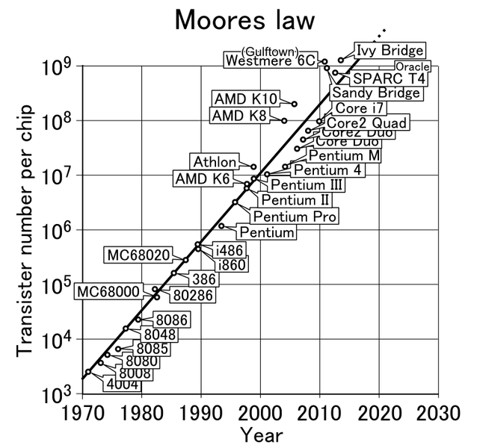
Fig. 1.1. Trends in device count/chip and feature size of MOS devices [Cringely 2013].
More than one-million fold increase in the device count within the ICs has been achieved among fifty years leading to almost an equivalent increase in processor performance. This has been driving the enormous development of electronics and information technology [Chu 2010]. Table 1.1 shows the clock frequency, manufacturing technology, total number of transistor count, thermal design power (processor is expected to dissipate maximum amount of power (generally expressed in watt) to prevent overheating under any workload) and maximum temperature allowed at the processor die (Junction temperature) of significant Intel processor evolved till 2014 [Intel 2014].
Table 1.1. Specifications of significant Intel processor [Intel 2014]
Processor Name | Clock frequency (GHz) | Manufacturing Technology  (nm) | Total no. of Transistors  (million) | Thermal Design Power  (Watt) | Junction Temperature  (ºC)
Intel® EP80579 | 1.00 | 90 | 148 | 20 | 97
Intel®  Pentium®  3550M | 2.90 | 22 | 1300 | 37 | 100
Intel® Core™2  Duo T5670 | 1.80 | 65 | 291 | 35 | 100
Intel® Core™  i3-560 | 3.33 | 32 | 382 | 73 | 72.6
Intel® Core™  i5-760 | 2.80 | 45 | 774 | 95 | 72.7
Intel® Core™  i7-4765T | 3.00 | 22 | 1400 | 35 | 66.35
With device scaling approach in the sub-micron technology the other parameters like speed, reliability and power dissipation, on-chip temperature generation have shown a trade-off nature among them. In this thesis, effective solutions are proposed for the optimization of the device parameters like area (number of gates/nodes), power dissipation and the effect of temperature at the logic level. The elaborate discussion on area, power and temperature reduction techniques in different forms of logic networks are explained in the contributory chapters of this thesis. Next section illustrates the trends of power dissipation with technology scaling.
  - Power Dissipation Trends
The CMOS power dissipation has become a very hot topic during the last few decades because all technology is dominated by CMOS devices. Almost all the modern era electronics gadgets (e.g. mobiles, laptops, palmtops etc.) are battery-powered. Because of rapid technology scaling, more numbers of functional modules are integrated into a system. This has resulted in an exponential increase of power. That has enforced huge challenges and threatens to slow down the momentum. Fig. 1.2 shows a power dissipation trends of system-on-chip (SOC) based devices as per ITRS 2010.
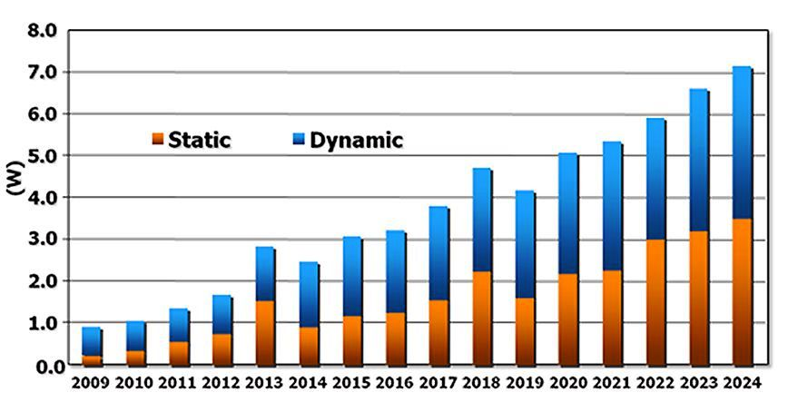
Fig. 1.2. Power trends of SOC based devices [ITRS, 2010 Update].
It is evident from the Fig. 1.2. that the power consumption in CMOS devices is mainly classified into two catagories- dynamic and static power dissipation. Sources of these types of power dissipations are discussed below:

    - Dynamic Power Dissipation
Dynamic power dissipation mainly consists of glitching power, short circuit power and switching power. A brief discussion on these three categories is discussed below:
      - Glitching Power Dissipation
The power dissipation due to intermediate spurious transitions during the evaluation of a logic network is termed as glitching power. When the inputs to the logic gates are not synchronized, in accurate results occurs at the output node until all the inputs settle down to their final values. These intermediate flawed outputs lead to a power loss in charging and discharging the output load capacitances. The glitching power can be estimated by equation 1.1 [Lu and Agrawal 2006].
(1.1)
In equation 1.1, V_{DD} is the supply voltage, C_{L} is the net loading capacitances consists of gate input capacitancs, interconnect capacitancs, diffusion capacitances of the drain of a transistor. f_{glitch} represents the average frequency of the glitches. For a large network, the glitching power may consume upto 40% of the total switching power. Usually cascaded networks generate high glitching power dissipation. By balancing delays within the networks and utilizing synchronous circuits the glitching power can be minimized. If possible, cascade network can be avoided and insertion of buffers on highly loaded nodes can be used to minimize glitching power.
      - Short Circuit Power Dissipation
During the transition of signals for finite rise and fall time, both PMOS and NMOS transistors, get simultaneously ON. Circuit current will find a path directly from V_{DD} to ground, hence creating a short-circuit path. Short-circuit power dissipation increases with rise and fall time of the transistors. The short circuit power of a network can be calculated by equation 1.2.
(1.2)
Where, I_{short-circuit} is the average short circuit current. Short circuit power dissipation can be minimized to 5-10% of the total power by proper sizing of CMOS transistors to obtain equal rise and fall times [Bellaouar and Elmasry 2012].
      - Switching Power Dissipation
The switching power dissipation is the main contributor to total average power dissipation. It adds around 80-90% of the total power consumption. The internal node capacitances and output load capacitance of a logic network are continually charged and discharged because of signal transition, which leads to switching power dissipation within a network. It can be evaluated by equation 1.3 [Pradhan and Chattopadhyay 2012].
(1.3)
Where, α_{L} and α_{i} are the switching activity at the load and internal node respectively. The capacitance at the load and internal gates are represented by C_{L} and C_{i} respectively. Supply voltage, threshold voltage and frequency of operation are given by V_{DD}, V_{T} and f respectively. Equation 1.3 illustrates that, other than switching activity all the parameters are user/manufacturer defined at a particular technology. Switching activity, being only technology independent parameter needs to be considered for technology independent power optimization. Expected number of signal transitions at the outputs of the gates of a combinational logic circuit is defined as switching activity. Switching power dissipation of a technology independent logic network can be estimated by following procedure.
Let, P__{on}[f] = ON-probability of function f
P__{off}[f] = OFF-probability of function f.
Then, ON and OFF state probabilities of switching function can be estimated as:
P__{on}[f]=P__{on}[x_{i}]. P__{on}[f_{xi}]+P__{on}[x_{i}]. P__{on}[f_{xi}]
= P__{on}[x_{i}]. P__{on}[f_{xi}]+ (1-P__{on}[x_{i}]). P__{on}[f_{xi}]
P__{off}[f] = P__{off}[x_{i}]. P__{off}[f_{xi}]+P__{on}[x_{i}]. P__{off}[f_{xi}]
= (1-P__{on}[x_{i}]). (1-P__{on}[f_{xi}])+ P__{on}[x_{i}]. (1-P__{on}[f_{xi}])
Let, transition probability of a switching function f can be estimated as
P__{switching}[f] =P__{on}[f]. P__{off}[f] + P__{off}[f]. P__{on}[f]
= 2. P__{on}[f]. P__{off}[f] = 2. P__{on}[f]. (1-P__{on}[f]) (1.4)
Considering equal and uniform input probability, P__{on}[f] can be further simplified as:
P__{on}[f] = 0.5 P__{on}[f_{xi}] + 0.5 P__{on}[f_{xi}] (1.5)
Switching probability and ON-probability of a Boolean function can be estimated using equation 1.4 and 1.5 respectively.
    - Static Power Dissipation
During inactive phase of CMOS transistors, the power loss for different leakage mechanism is termed as static power dissipation. Usually, small fraction of power dissipation is contributed by static power dissipation. When the number of transistors per chip increases and threshold voltage (V_{T}) decreases the static power contribution become major concern [kim et. al. 2003; Ekekwe 2010]. The sources of static power in digital circuits are mainly due to three components and they are briefed as:
      - Reverse Biased Diode Leakage Current (I_{diode-leakage})
This occurs when a transistor is turned OFF, and another active transistor charges up/ down the drain with respect to the former’s bulk potential.
      - Sub-Threshold Leakage Current (I_{sub})
Underirable leakage current flows between the drain and source when gate voltage is below the threshold voltage V_{th}, or very close to it. Sub-threshold leakage current is induced by the diffusion of the minority charge carriers from the source to the drain.

      - Oxide Tunneling Leakage Current (I_{tunnel})
Electrons can tunnel through the gate oxide because of low oxide thickness, leads to the induction of gate tunneling leakage current.
The total leakage current of a device is calculated by summing all the major contributor of leakage current. And the leakage power dissipation is calculated by equation 1.6.
(1.6)
Where, I_{leakage} is the leakage current and V_{DD} is the supply voltage. The proper choice of device technology should be encouraged to control minimum gate leakage during inactive and active modes of the transistors.
  - Temperture Trends
Temperature trend is studied under two catagories- power-temperature trends and technology scaling-temperature trends.
    - Power-Temperature Trends
The power dissipation in a CMOS circuit is manifested in the form of heat. During signal transition, the applied voltage leads to a lateral electric field and accelerates the charge carriers to move from source to drain. When a charge carrier colliding with other charge carriers and atoms, gained kinetic energy releases part of their energy causing vibrations and consequently there is a rise in the temperature. Reliability and timing failure of electronic chips are due to high on-chip temperatures. In reality, elevated temperatures, sudden spatial or temporal temperature variations, and presence of hot spots are the major cause of many electronic circuit failure. Even though, temperature variations across a VLSI chip can result in significant timing uncertainty, prompting wider timing margins, and thus, lower circuit performance. Another major concern is uneven power dissipation, which can produce mechanical stress, and may degrade the chip reliability. Figure 1.3. shows the power-temperature variation at 45nm and 90nm technology nodes. It is observed that at 90nm technology node leakage power increases more than linearly with temperature. At 45nm technology node, leakage power increases quadratically with temperature, nearly dynamic power consumption at higher temperature.
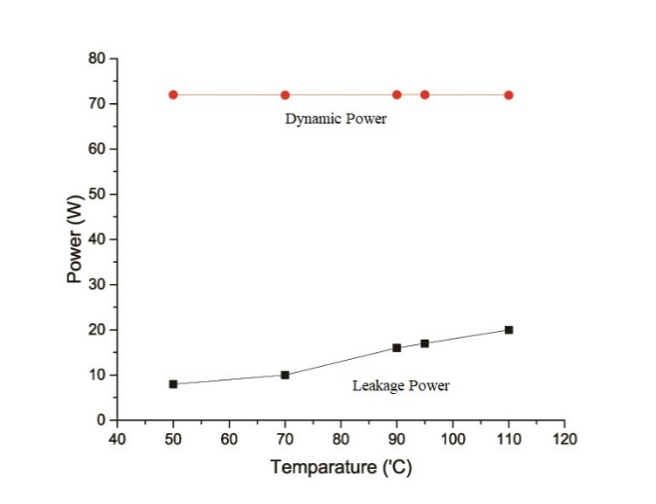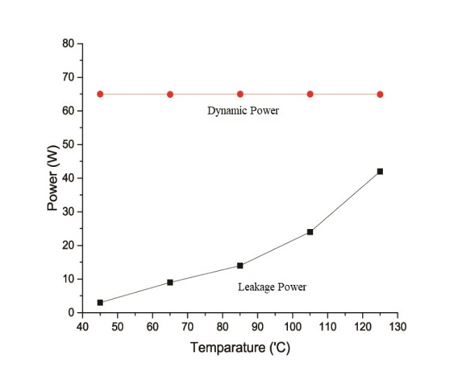
- at 90nm technology node (b) at 45nm technology node
Fig. 1.3. Power variation with temperature at 45nm and 90nm technology node.
    - Technology Scaling-Temperature Trends
With aggressive technology scaling, the electronic ICs become denser, faster and cheaper. More number of functional modules are embedded and power consumption become high with increasing scaling of technology. Because of which power density increases. High power density plays a key role to increase the chip temperature. The operating temperature of a VLSI chip can be calculated by the equation 1.7 [Pedram and Nazarian 2006].
(1.7)
Where, T_{chip} and T_{a} are the average chip temperature and the ambient temperature respectively. R_{Ɵ} is the equivalent thermal resistance of silicon substrate and heat sink. P_{total} and A are the total power consumption and the chip area. It is evident from equation 1.7 that power density of a chip increases as the power dissipation increases and it leads to the generation of high temperature regions called hot-spots. Consequently, the chip temperature can be high, and there can be reliability failure and yield loss. Electronic devices are operated effectively within safe temperature range specified by the manufacturer. The maximum operating temperature zone for aerospace and military devices are very broad (-55 ^{O}C to 125 ^{O}C). Whereas, commercial (0 ^{O}C to 70 ^{O}C) and industrial (-40 ^{O}C to 85 ^{O}C) devices are operated within much lower temperature zone [Electronics COOLING 2004]. For safe and reliable operation, devices should be operated below maximum limiting temperature. So, reduction of temperature is becoming a big challenge. However, at the logic synthesis level, the absolute value of temperature is unknown. So far the works in thesis are concerned, the effect of temperature is captured at the logic synthesis level by considering power density. Fig. 1.4 illustrate the trends of power density with technology scaling.
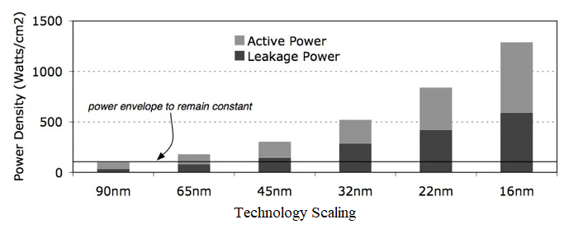
Fig.1.4. Power density trends with increasing technology [Fox 2018].
  - Optimization Paradigm
In this section, a motivational explaination is given to cater the need for thermal aware design at the logic level. As stated in the previous section, the power density that directly converges to temperature has a relevant impact on the area and power dissipation of a circuit. Though, there exist different low power management approaches that increases the battery life time, to the best of our knowledge, there are no synthesis approaches that incorporate temperature dependence along with area and power at the logic level. For this reason, technology independent logic level is targated to optimize the temeperature (power density) along with area and power. Different forms of encoding techniques are studied for different synthesis approaches that have been discussed in next section. Because of technology independent, total number of gates are considered as area utilization. At logic level, total power dissipation in watt (W) is unknown, so the switching activity is considered as the power constrain. The switching activity calculation is explained in section 1.3. Peak temperature or average temperature in degree centigrade (ºC) is also unknown at higher levels of VLSI design. But the effect can be analysed and controlled by limiting the power density of a circuit. Therefore, for the optimal realization of the circuit, area (number of logic nodes), power (switching activity) and temperature (power density) is incorporated during the fitness calculation of the optimization process.
Because of large search space of circuit decomposition based on input or output polarity; or input variable ordering, finding an optimal polarity or variable ordering for considered optimization is a Non-deterministic Polynomial (NP) complete problem [Murgai et. al. 1999]. To solve the problem, two meta-heuristic evolutionary algorithm, Genetic Algorithm (GA) and Non-dominted Sorting Genetic Algorithm-II (NSGA-II) is considered. A weighted search GA is used in this thesis, to study the trade-off nature among the considered objective parameters. But weighted search GA is unable to specify the exact weight combination of each parameters for optimal solution. For this reason, to find the optimal solution NSGA-II is employed. NSGA-II provides a Pareto optimal solution set in a single run which include best individual solution and optimal solution. It also reduces the total execution time.
Algorithmic optimized results depict only representative values for area, power, and temperature. To validate the results obtained from the algorithm, the best and optimum solutions are implemented in physical design domain to obtain the real world values for the area in micrometer, power in nano-watt and temperature in degree centigrade. The solutions are first synthesized using Cadence Genus tool and synthesized solutions are fed into Cadence Innovus tool for obtaining actual silicon area utilization and power dissipation. The floorplan information (.flp) profile is created using silicon area utilization and power profile (.pptrace) is created from power dissipation information. These two files are taken as input to the HotSpot tool [Huang 2006; HotSpot 2015] to obtain the temperature profile. The total area from floorplan information, power dissipation from power profile and peak temperature in degree centigrade from temperature profile are reported for each benchmark circuit. The thermal packaging constraint in HotSpot tool configurations are tabulate in Table 1.2.
Table 1.2. Thermal package parameters used by HotSpot tool
Thermal package Parameters | value
chip thickness | 0.15mm
convection capacitance | 140.4 J/K
convection resistance | 0.1 K/W
heat sink side | 60mm
heat sink thickness | 6.9mm
spreader side | 30mm
spreader thickness | 1mm
chip to spreader interface thickness | 0.020mm
Ambient temperature | 45 ⁰C
The flow diagram of proposed area, power and thermal-aware optimization model is shown in Fig. 1.5.
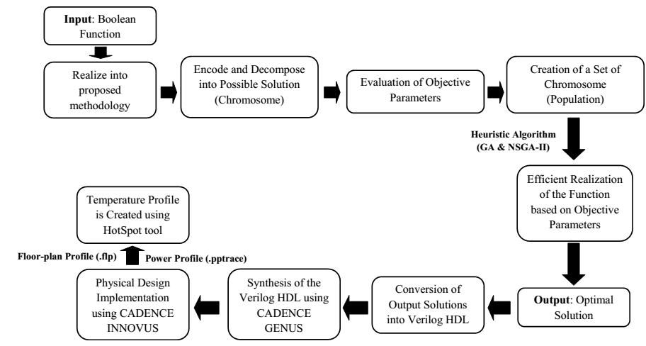
Fig.1.5. Proposed Optimization model flow diagram

  - Problem Formulation
In the face of the critical challenges to deal with the area miniaturization, power consumption and excessive heat generated by the logic devices today, area, power and thermal-aware design techniques are urgently demanded from all perspectives and design abstraction levels. To tackle this problem, efforts have been made by researchers earlier at every design abstraction level including circuit level, logic level, architectural level and system level. In this thesis, the focuss is to address this problem in the logic level. As the logic synthesis targets the optimization in technology independent manner, technology based optimization is basically done at gate level. Accordingly, many heuristics have been proposed in order to optimize the circuit parameters like area, power and delay etc., as noted in the state-of-art survey in chapter 2. Based on the survey, following are the problems sorted out in order to optimize the design in the logic level domain.
    - Output Polarity Selection based on AND-INVERTER Graph
Multi-output combinational logic circuits are realized in the form of AND-OR based Programmable Logic Arrays (PLA) with suitable output polarity in order to meet the goal of optimization in terms of area, power and temperature. Individual sub-functions are decomposed in positive or negative polarity form in order to maximize the sharing of product terms among the sub-functions. The approach has been utilized effectively in [Chaudhury and Chattopadhyay 2006; Pradhan and Chattopadhyay 2008] to reduce the area and power of the PLA based circuits. In two-level synthesis, there may be redundant polarity which may give same solution but it realizes different multi-level circuit. Detail discussion of the multi-level realization PLA circuit is given in chapter 3. In this thesis, the polarity of output sub-functions are choosen based on area, power and temperature value realized after decomposing a PLA circuit into AND-INVERTER Graph based multi-level circuit. Temperature is also incorporated with area and power of a particular realization. A weighted search GA is used to analyses the trade-off nature lie among the area, power and temperature. NSGA-II is used to get the Pareto optimal solution set. Physical design validation is done using CADENCE Genus and Innovus; and HotSpot tool.
    - Fixed Polarity AND-XOR and OR-XNOR based Decomposition
In many real-life circuits, used in the fields of coding theory, telecommunication, linear system, computer arithmetic coding, error detection-correction, data encryption and decryption are inherently the basic functions of mod-2 sum form. In such cases, Reed-Muller minimized algorithms often produce more compact circuit than the AND-OR based realizations. When Reed-Muller circuits are realized as PLA, it offers high testability. Due to their wide applicability, Reed-Muller logic based circuit synthesis for area, power and temperature minimization has been carried out. GA and NSGA-II based approach have been carriedout in both cases. A physical verification is also done at 45nm technology. In fixed polarity based decomposition, two specific tasks have been addressed.
      - Fixed Polarity Reed-Muller (FPRM) based Decomposition
In FPRM form, the input variables of a multi-input multi-output (MIMO) Boolean network is assigned with either positive or negative polarity. The network is decomposed based on AND-XOR based Davio function (as discussed in chapter 5) in order to get area, power and thermal-aware optimized fixed polarity Reed-Muller expression.
      - Fixed Polarity Dual Reed-Muller (FPDRM) based Decomposition
In FPDRM form, the input variables of a Boolean networks are encoded into either positive or negative polarity. The network is decomposed based on OR-XNOR based function in order to get area, power and thermal-aware optimized fixed polarity Reed-Muller expansion. A parallele tabular technique is developed for polarity decomposition (Chapter 5).

    - Mixed Polarity AND-XOR and OR-XNOR based Decomposition
A Boolean function represented in Reed-Muller (RM) form is unique and canonical in nature, as well as it is in readily testable form [8]. Depending on application, RM circuits are expanded into Fixed Polarity Reed-Muller (FPRM) and Mixed Polarity Reed-Muller (MPRM) expansions. After a thorough search in the literature, it is seen that optimization of MPRM is superior over the FPRM expansions on circuit performance with respect to the area, switching activity (dynamic power) and/or delay [Chaudhury and Chattopadhyay 2008; Wang et. al. 2012]. But none of the articles has addressed the temperature effect during RM form of circuit synthesis. The work carried out in this thesis addressed mixed polarity based decompositions for its area, power and thermal-aware realization using GA and NSGA-II based synthesis.
      - Mixed Polarity Reed-Muller (MPRM) based Decomposition
In MPRM form, the input variables of the Boolean networks are assigned with positive and/or negative polarity at the same time in a given expression. The network is decomposed based on AND-XOR based Davio function in order to get area, power and thermal-aware optimized mixed polarity Reed-Muller expansion.
      - Mixed Polarity Dual Reed-Muller (MPDRM) based Decomposition
In some domain, the circuit realized with OR-XNOR provides a better solution than AND-XOR based realization. An attempt is made to realize a Boolean network to encode into MPDRM form, where input variables are encoded into positive and/or negative polarity. The networks are decomposed based on OR-XNOR based function in order to get area, power and thermal-aware optimized fixed polarity Reed-Muller expansion.
    - Reduced Ordered Binary Decision Diagram (ROBDD) based Synthesis
After addressing the input variable and output sub-functions polarity encoding techniques for thermal-aware issues along with area-power trade-offs in the domains of two-level and multi-level circuit synthesis, next, experimentation is done with input variable ordering during the multilevel circuit synthesis using binary decision diagram (BDD). In the proposed work, the BDD in the form of reduced order binary decision diagram (ROBDD) is considered for the maximum sharing of the logic nodes. GA and NSGA-II are used to select the proper variable ordering of SROBDD structure for optimum realization of logic circuit in terms of area, power and temperture.
  - Structure of the Thesis
The presented work of this thesis are organized into 4 categories: (i) analysis of the state-of-the-art work in the field of power and thermal aware design, (ii) study of the area, power and temperature trade-offs at logic level during thermal aware synthesis using Genetic Algorithm, (iii) NSGA-II based optimization for area, power and thermal-aware realization and (iv) physical level realization of optimized circuit using CAD tool to get an estimation of absolute area (in µm²), power dissipation (in nW), and temperature (in °C) for integrated circuit implementation. Chapter wise contributions of this thesis work are as following:
Survey on state-of-the-art techniques for the reduction and optimization of area, power and temperature variations in different VLSI level of abstraction is explained in chapter 2. Prior logic synthesis heuristics in two and multi-level have been discussed. A detailed survey on each problem statements are also discussed elaborately. Two meta-heuristic evolutionary algorithm, GA and NSGA-II for finding optimal variable polarity or variable ordering are also described in chapter 2. GA consideration and process flow diagram are carefully illustrated. The advantages and disadvantages of GA based optimization are also reported. To overcome the disadvantages of GA, NSGA-II is formulated. Complete process flow diagram is elucidated in chapter 2. The concept of non-dominated sorting and crowding distance calculation is also explained.
Chapter 3 demonstrates the impact of efficient power density based logic synthesis (in the form of suitable polarity selection of sub-function of Programmable Logic Arrays (PLAs) for its multi-level realization) for the reduction of temperature. Two-level PLA optimization using output polarity selection is considered first and results are compared with other existing techniques and then And-Invert Graphs (AIGs) based multi-level realization has been considered to overcome the redundant solution generated in two-level synthesis. AIGs nodes and associated power dissipation can be reduced by rewriting, refactoring and balancing technique. Reduction of nodes leads to the reduction of the area but on the contrary increases power and power density of the circuit. GA and NSGA-II based meta-heuristic search approaches are proposed to select the suitable output polarity of PLA sub-functions for its optimal realization.
Chapter 4 investigates the impact of input variable encoding in fixed polarity Reed-Muller and Dual Reed-Muller based circuit for its thermal-aware realization along with area and power optimization. GA and NSGA-II are used to find a suitable variable polarity for the enumeration of trade-offs nature among the area, power and temperature.
In chapter 5 an attempt is made to reduce the effect of power density along with area and power so that AND-XOR or OR-XNOR based circuit is balanced in terms of area, power, and temperature. AND-XOR based Reed-muller mixed polarity and OR-XNOR based Dual Reed-Muller mied polarity circuit forms are considered in this work. Polarity conversions are made in such a way that possibility of maximum sharing among the sub-function is increased. GA and NSGA-II are used to select the polarity of the input variable for maximum sharing. A trade-off is also reported based on MPRM and MPDRM based circuit realization.
Chapter 6 elucidates the idea of adopting GA and NSGA-II based approach for the thermal-aware realization to trim down the excessive heat by eliminating local hotspots within a densely packed IC by shared reduced ordered binary decision diagram. As the temperature is directly proportional to power density, most of the circuits are burnt because of local hotspot generated by excessive heat. So, an attempt is made to reduce the tremendous increase of temperature by limiting the power density. In this investigation, GA and NSGA-II based meta-heuristic evolutionary algorithm are used for selecting a suitable input variable ordering to construct BDD for Boolean functions for its reduced order form for maximum sharing among the sub-functions. Cadence Innovus and HotSpot tool are used to determine the actual silicon area, power dissipation and peak temperature of algorithmic optimized solutions.
Chapter 7 finally draws the conclusion to the works carried out in this thesis and enumerates some possible directions for future work.
  - Summary
In this chapter, the importance of thermal-aware design parameter optimization during the synthesis of modern VLSI circuit is illustrated. As technology scales down, not only the power, but also the temperature needs to be considered for efficient circuit realization, otherwise circuit will get burn out due to thermal run-away. Here the trends on technology scaling, power and temperature have explained. Detail discussion on the problem formulation for thermal aware optimization in the Boolean logic has been presented also in this chapter. State-of-the-art literature survey on the area, power and temperature variations in different VLSI level of abstraction is elaborated in chapter 2.
References
Gunther, S., Binns, F., Carmean, D. M. and Hall, J. C., (2001), “Managing the impact of increasing microprocessor power consumption”, Intel Technology Journal, Vol. 5, no. 1, pp. 1-9.
Pedram, M., and Nazarian, S., (2006), “Thermal modeling, analysis, and management in VLSI circuits: Principles and methods”, Proceedings of the IEEE, vol. 94, no. 8, pp. 1487-1501.
Shang, L., Peh, L. S., Kumar, A., and Jha, N. K., (2004, December), “Thermal modeling, characterization and management of on-chip networks”, In Proceedings of the 37th annual IEEE/ACM International Symposium on Microarchitecture, IEEE Computer Society, pp. 67-78.
Hassoun, S., and Sasao, T. (2012), Logic synthesis and verification. Vol. 654. Springer Science & Business Media.
Hachtel, G.D. and Somenzi, F., (2006), Logic synthesis and verification algorithms. Springer Science & Business Media.
Mohanty, B. K., and Patel, S. K. (2014), “Area–delay–power efficient carry-select adder”, IEEE transactions on circuits and systems II: express briefs, vol. 61, no. 6, pp. 418-422.
Moore,G. E., (1965), “Cramming more components onto integrated circuits,” Electronics, v. 38, n. 8, pp. 114-117.
Moore, G. E., (1975), “Progress in Digital Integrated Electronics”, IEDM Tech. Digest, IEEE press, pp. 11-13.
Vassighi, A., and Sachdev, M., (2006). Thermal and power management of integrated circuits. Springer Science & Business Media.
Cringely, R. X. (2013), Breaking Moore’s Law, Computing, Cringely's Rules, history.
P. K. Chu, (2010), Advances in Solid State Circuit Technologies, Intech.
Intel, (2014 update), [online]: Available: https://ark.intel.com/
International Technology Roadmap for Semiconductors, 2010 Update.[Online]. Available: http://www.itrs2.net/
Lu, Y., and Agrawal, V. D., (2006), “CMOS leakage and glitch minimization for power-performance tradeoff”, Journal of Low Power Electronics, vol. 2, no. 3, pp. 378-387.
Bellaouar, A., and Elmasry, M., (2012), Low-power digital VLSI design: circuits and systems. Springer Science & Business Media.
Pradhan, S. N., and Chattopadhyay, S., (2012),“Multiplexer-based multi-level circuit synthesis with area-power trade-off”,. Journal of Circuits, Systems, and Computers, vol. 21, no. 05, pp. 1250037.
Kim, N.S., Austin, T., Baauw, D., Mudge, T., Flautner, K., Hu, J.S., Irwin, M.J., Kandemir, M. and Narayanan, V., (2003), “Leakage current: Moore's law meets static power”, computer, vol. 36, no. 12, pp.68-75.
Ekekwe, N., (2010), “Power dissipation and interconnect noise challenges in nanometer CMOS technologies”, IEEE potentials, vol. 29, no. 3, pp. 26-31.
The Temperature Ratings of Electronic Parts, Electronics COOLING, 2004, [online]. Available at: http://www.electronics-cooling.com/2004/02/the-temperature-ratings-of-electronic-parts/.
Fox, A., (2018), Why CPU Clock Speed Isn’t Increasing, Hardware Guides.
Murgai, R., Jain, J., and Fujita, M., (1999, January), “Efficient scheduling techniques for ROBDD construction”, Proceedings of IEEE Twelfth International Conference On VLSI Design, 1999., pp. 394-401.
Huang, W., Ghosh, S., Velusamy, S., Sankaranarayanan, K., Skadron, K., and Stan, M. R. (2006), “HotSpot: A compact thermal modeling methodology for early-stage VLSI design”, IEEE Transactions on Very Large Scale Integration (VLSI) Systems, Vol. 14, no. 5, pp. 501-513.
Pradhan, S.N. and Chattopadhyay, S., (2008, January), “Sub-function Polarity Selection of PLAs with Area-Power Trade-off”, Proceedings of International Conference on Systemics Cybernetics and Informations.
Chaudhury, S. and Chattopadhyay, S., (2006), “Output phase assignment for area and power minimization in PLAs”, Journal of Indian Inst. Sci., Vol. 86, pp. 33-43.
Wang, Z. H., Wang, P. J., Yu, H. Z., and Zhang, H. H., (2012), “Delay and area optimization for FPRM circuits based on PSO algorithm”, Journal of Circuits and Systems, Vol. 17, no. 5, pp. 75-80.
Chaudhury, S., and Chattopadhyay, S., (2008), “Fixed polarity Reed-Muller network synthesis and its application in AND-OR/XOR-based circuit realization with area-power trade-off”, IETE Journal of Research, Vol. 54, no. 5, pp. 353-363.

